|  |  |  |  |  |
| --- | --- | --- | --- | --- |
| **Modifier** | **Class** | **Package** | **Subclass** | **World** |
| **Public** | Y | Y | Y | Y |
| **Protected** | Y | Y | Y | N |
| **Default** | Y | Y | N | N |
| **Private** | Y | N | N | N |

//div[@class='clearfix']//div//h2//i

* Go to Project and click on Build Path
* Then Libraries window will open
* From Righthand side Select “Add Library”

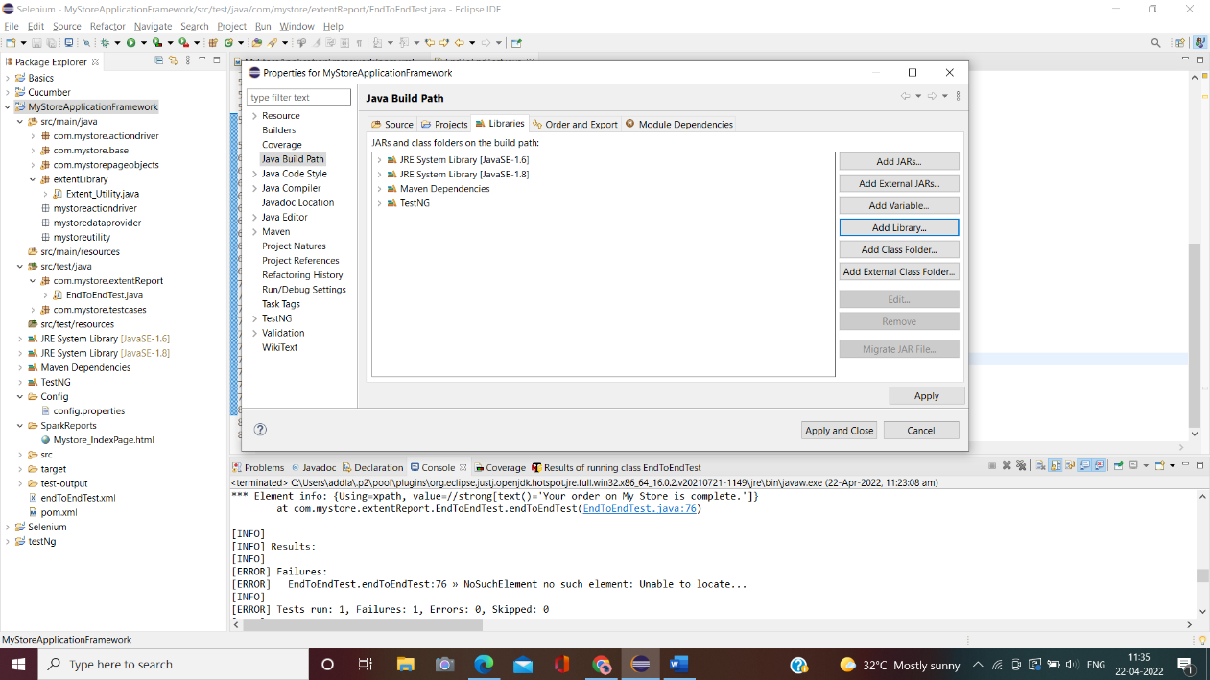

* Add Library window will open from that select JRE System Library

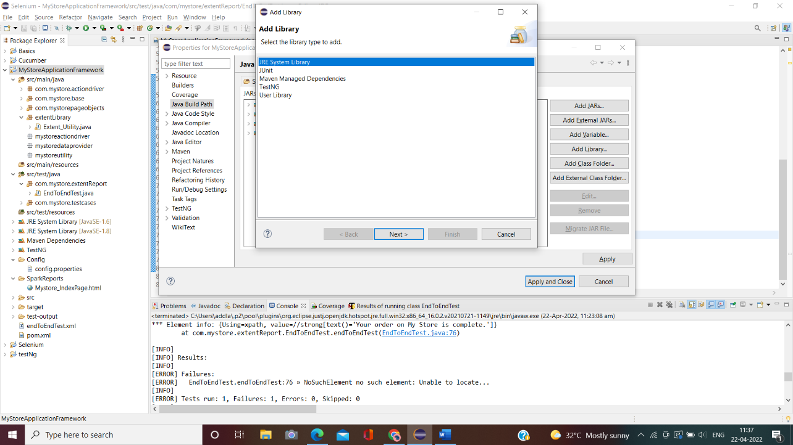

* JRE System Library window will open

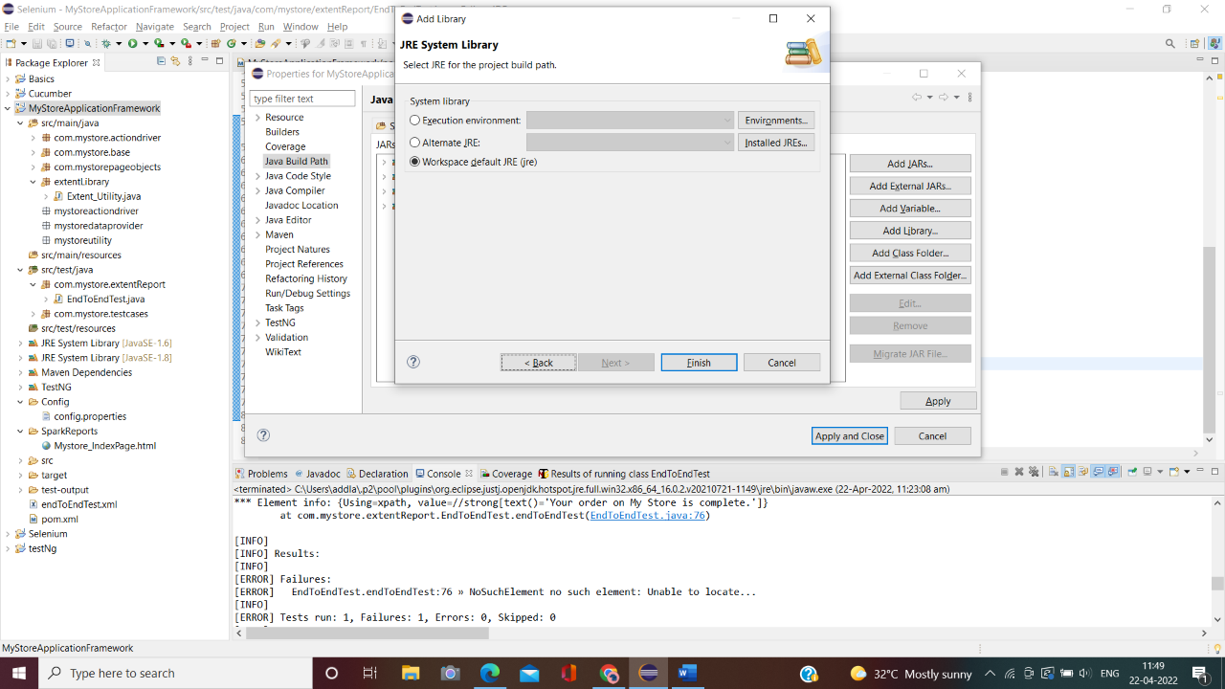

* Click on Execution environment and from right corner Environments

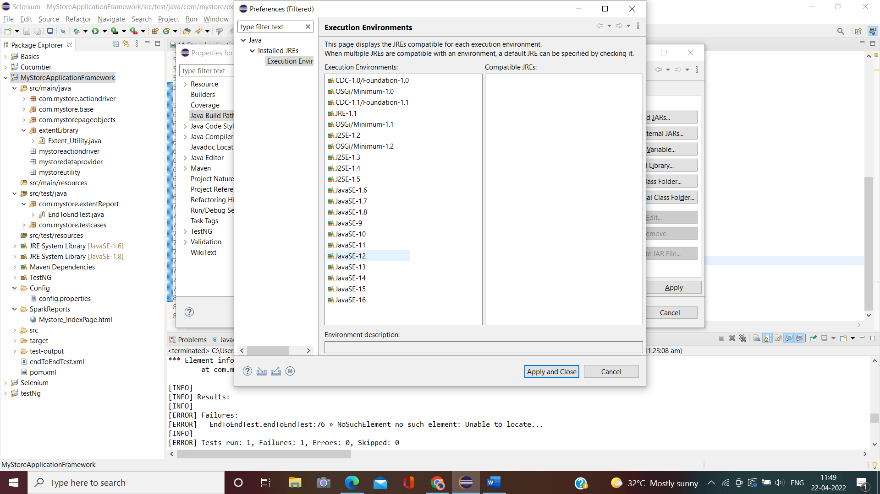

* Click Environments and Execution environment window, where it shows al the java version list